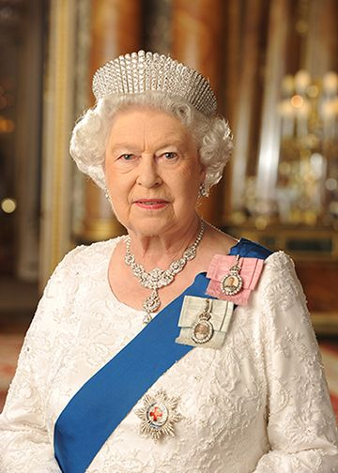

HRH Queen Elizabeth II

21st April 1926 – 8th September 2022

There is a Book of Condolence at Burnham Park Hall for members of the public to share their thoughts. It will be available 09.00 – 18.00 hrs, Monday – Friday until 17.00 hrs on the day of the funeral.