Dear Member
You may recall from Newsletter 113 that the draft Chiltern & South Bucks (C&SB) Local Plan – prepared in expectation that the pan-Buckinghamshire housing need would be met by greater development in Aylesbury Vale than in Wycombe, Chiltern and South Bucks – proposed that only three ‘brownfield’ sites in Taplow be removed from the Green Belt.
Before lockdown slowed the pace of life, we were active in preparing for the Hearings stage of the planning process which has now been postponed indefinitely. But we had not been made aware of some highly significant happenings. We are indebted to Bill Dax of Dorney Parish for bringing to our attention some unpleasant news we think you should be aware of.
Most immediately, Government Inspectors have stated that they are minded to reject the Local Plan on the grounds that it fails the ‘Duty to Cooperate’ requirement, apparently because it did not cater for Slough Unitary Council ambitions to meet its own housing requirement by expanding into South Bucks.
We think that the Government expected ‘Duty to Cooperate’ to always lead to agreement between local authorities but, in our crowded area of the south-east with its high Green Belt content, it is proving impossible to meet total Government-mandated housing requirements. The new Bucks Council (BC) is one of many local authorities contesting Inspectors views but the agreed process of resolution in face-to-face meetings is currently on hold during lockdown.
If BC wins the day, then presumably the draft Local Plan will roll forward through conventional hearings and eventually come into force, thus protecting the rest of Taplow’s Green Belt. But if the Inspectors are successful, or other issues cause it to be rejected, the draft C&SB Local Plan will have to be recast and re-consulted on before re-submission, with the risk that Taplow and its rural neighbours could be under increasing threat of development. Details of the contrary positions of Slough and C&SB / BC can be found at these weblinks….
http://www.slough.gov.uk/downloads/171004_AtkinsSlough_NorthernExn_Report.pdf
https://www.southbucks.gov.uk/article/10406/Local-Plan-Examination
We have been made aware that C&SB reacted to the possible rejection of its Local Plan as early as 2017 by rather quietly beginning collaborative studies with Slough and the Royal Borough of Windsor & Maidenhead (RBWM). The BC has succeeded C&SB in this triumvirate which treats the area of South Bucks south of the M40 not as part of Buckinghamshire but, sandwiched as it is between Slough and Maidenhead, as part of a much more densely populated M4 / Crossrail corridor.
These studies comprise:
- The Wider Area Growth Study (WAGS) will be “part of the evidence base to supporting future plan making and Duty to Cooperate work between authorities” (my italics).
- A Local Housing Needs Assessment (LHNA) “to look at the amount and nature of housing need within the Royal Borough of Windsor & Maidenhead, Slough and the southern part of South Bucks [south of the M40] (my italics)
- Part 1 of the WAGS and the LHNA were published in 2019. They can be examined at these weblinks…
http://www.slough.gov.uk/downloads/WiderAreaGrowthStudy-Part1Report.pdf
http://www.slough.gov.uk/downloads/RBWM-Slough-SBucks-LHNA.pdf
The LNHA concludes that some 14,540 dwellings are needed over a ten-year period in an area which includes most of South Bucks (see below). The relation of this number to those currently in the C&SB, Slough and RBWM draft Local Plans is unclear but there is an evident threat that the rural South Bucks could be obliged to solve urban Slough’s problems in achieving perceived need for housing.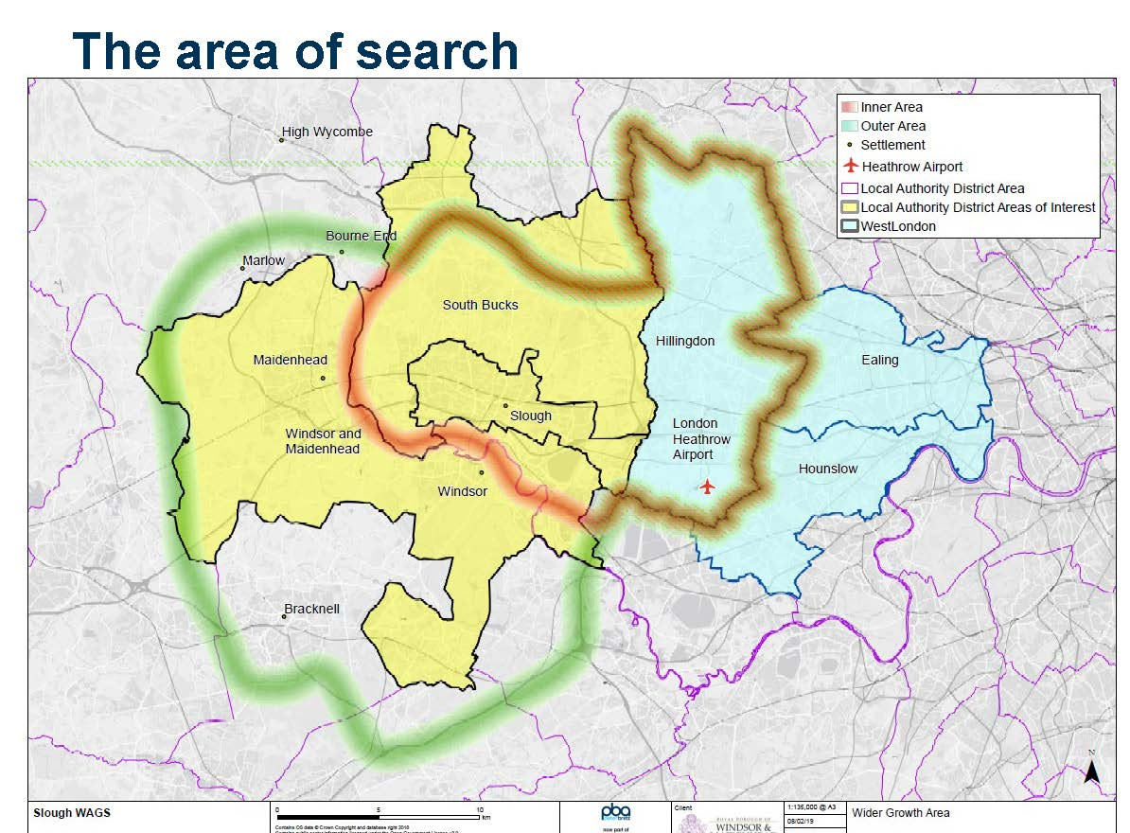
Part 2 of the WAGS is nominally due in October 2020. It “..will identify potential strategic spatial options for accommodating future development needs of the Slough / Maidenhead and Windsor urban area, test these options and make recommendations for consideration in relevant Local Plans and for use in Duty to Co-operate discussions” (my italics).

We are disappointed that, although these studies are accessible online, their existence has been kept quiet by C&SB and by the BC despite their potentially high impact. It is unclear how they will play into recast Local Plans but, bad as the draft C&SB Local Plan may be, a recast one based on these studies is likely to be worse news for Buckinghamshire’s green tail.
We need to consider what effective representations might be made to BC and the Government as the latter prepares yet another Planning White Paper.
Bill Dax has an excellent article in the July edition of the Dorney Parish News which carries some of our comments within it.
Roger Worthington Secretary, HTS

