**St Nicolas Church Taplow**

**Bonfire and Bangers**

**Taplow Rectory Garden**

**Saturday 13th October at 6pm**

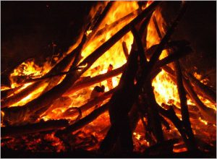  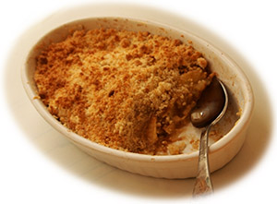

Everyone is welcome to a fun evening in the rectory garden

Plenty of seating for those who need it

Gazebos to provide shelter

Music from St Nicolas Quartet – Bonfire

Sausages from the barbecue – Homemade apple crumble

Raffle with superb prizes

Open Bar

It helps with catering if you are able to book in advance

***Tickets £5 entry including food***

***Children five and under FREE***

***Wine, beer, soft drinks for sale***

***Music from St Nicolas Quartet***

***For tickets please contact:***

***Carole Oliver***

01628 314642 or [caroleoliver1@sky.com](mailto:caroleoliver1@sky.com)