The Friends of St Nicolas Church Taplow

A new forum with the purpose of increasing awareness of the needs of our Church building & land and to support the raising of funds to secure its future.
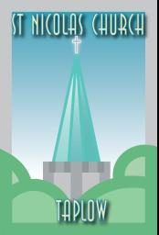

Our Church means many things to us as individuals, families and as a community:

- Somewhere to join others in collective worship and to celebrate festivals either occasionally or regularly.
- A beautiful historic building.
- A well-known Taplow landmark.
- Somewhere of special importance and memories for us, such as wedding’s funerals and baptisms.
- A place to enjoy concerts and other community events.
- A timekeeping aid with an accurate chiming clock!

If St Nicolas means at least one of these things to you, I’m sure you would be interested in hearing about the plans to restore and secure the building.

Please come along to an informal evening of information and ideas. Everyone is welcome.

Thursday 30th April 7.30 pm St Nicolas Church Taplow

For more information or to share ideas contact Nicki Jeffries 07801504681 / paxcottage@aol.com

