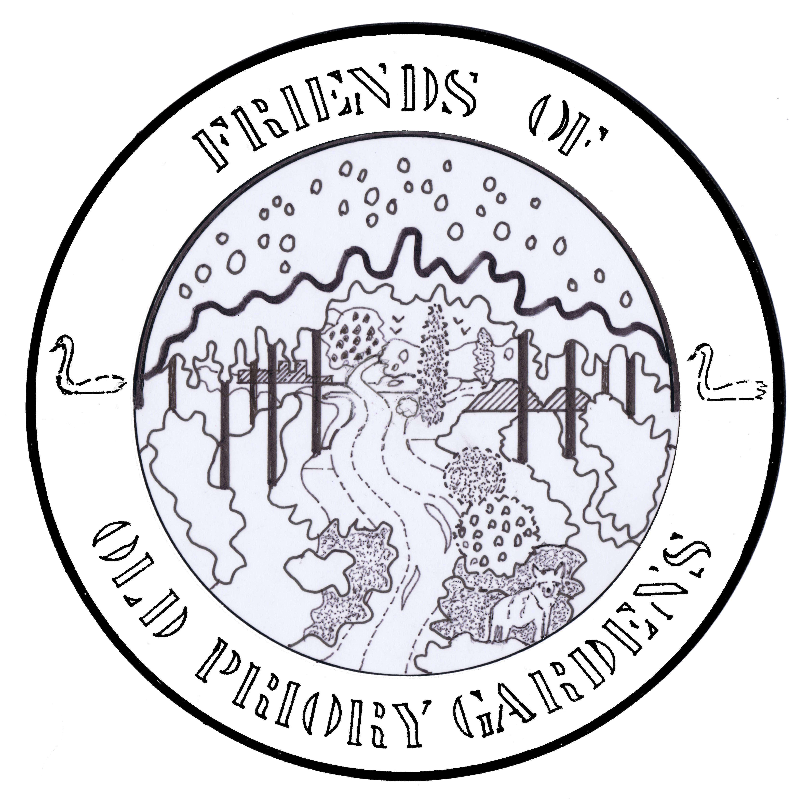

Out of the Woods

Issue 1 April 2014

The newsletter for the Friends of Old Priory Garden

It’s stopped raining (more or less), the sun is shining (more or less), and the clocks are about to go forward. Spring is here, filling hearts with hope, muscles with energy, and Old Priory Garden with renewed life as the seasonal cycle steps up a gear. What better time to get out and enjoy its natural delights… and launch an accompanying newsletter into the bargain. Out of the Woods will be with you every other month.

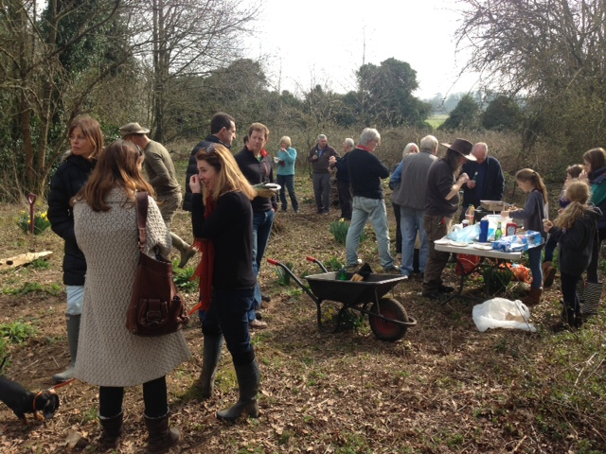After the wettest winter on record, work on OPG began in earnest at the beginning of March. A work party cleared bramble and nettles, cut ivy from trees, swept paths, cleared the leaves from the pond, cut back the foliage from the little bridge by the pond, and chowed down on pulled pork rolls and hot dogs (left). Since then, further work has been completed: the south end of the clearing has now been edged with logs to mark a curved border, the two paths to the pond have been joined up to provide a complete horseshoe route, and log piles are being created for insects to thrive in.

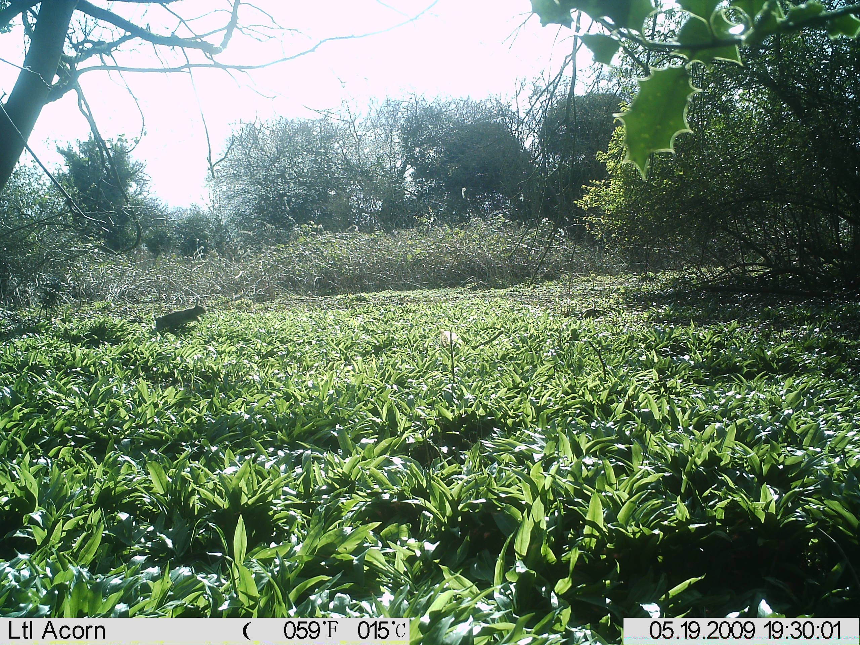Spring wildlife has also been stirring. Blue and great tit activity has been seen in and out of at least three of the bird boxes so far, roe deer have been spotted early in the morning near the pond, and a buzzard has been recorded sitting only just above head height in one of the trees. It’s impossible to miss the drumming of great spotted woodpeckers – short bursts of beak against bark, done to advertise territory. It’s been calculated that the birds can slam their beaks against trees with a force up to 1,000 times that of gravity – a combination of sturdy neck muscles, a long tongue that cushions the brain, and spongy skull bone prevents woodpeckers from head and brain damage.

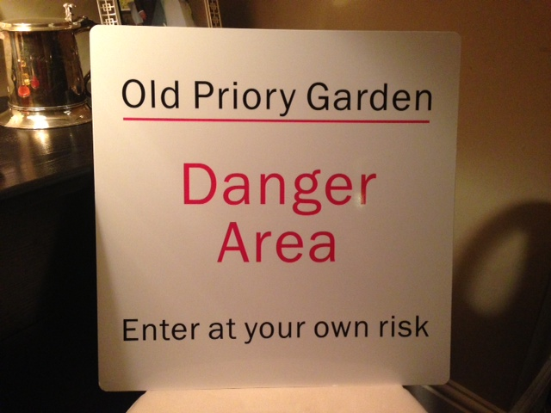It’s also impossible to miss the wild garlic (above) which is building up to its flowering phase once more. Unless you have a very, very heavy cold, simply follow your nose and it will lead you to the carpet of dark leaves that surround the north end of the pond. If you feel inclined to try Taplow wild garlic in your own cooking (and why not?), remember you only need to pick the leaves.

Several of the trees suffered during the winter storms. As the ‘Danger’ notice shown right implies, we do advise you to stick to the footpaths as much of the Garden is still very wild and has not yet been made safe.

But if you DO decide to confront nature in all its wildness, we’d love to see you.   
**The next working party is on Saturday 5 April**, and even if you can only manage an hour or two, or perhaps just a cheery wave of encouragement, you’ll be very welcome.

See you there.

